# Price Sensitivity Measurement (PSM) Analysis

## What is PSM?

PSM (Prise Sensitivity Measurement) analysis is a method of asking four questions about the price of a product or service. PSM is an analytical method to derive an "upper price limit", a "compromise price", an "ideal price", and a "lower price limit”. PSM can analyze consumer sensitivity to price with only four questions below.

1. At what price would you consider the product to be so expensive that you would not consider buying it?
2. At what price would you consider the product starting to get expensive, so that it is not out of the question, but you would have to give some thought to buying it?
3. At what price would you consider the product to be a bargain - a great buy for the money?
4. At what price would you consider the product to be priced so low that you would feel the quality couldn't be very good?

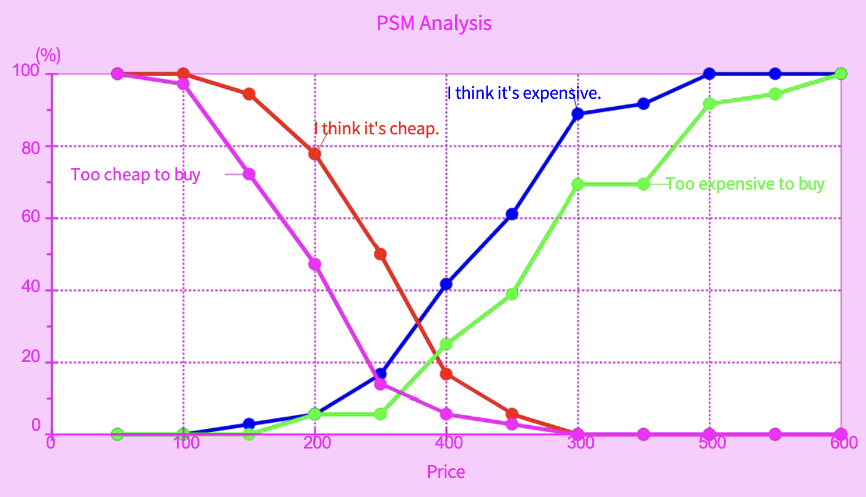

## Problem in Pricing

Apart from cases where the approximate market price is fixed, such as cigarettes or weekly newspapers, pricing is an extremely sensitive and difficult issue. Product that is priced too high won’t have many sales, while a product that is priced too low won’t generate much profit for businesses.

Businesses want to sell their products at the highest possible price because they are good products, but consumers, on the other hand, want to buy them at a price they are willing to pay.

PSM analysis (Prise Sensitivity Measurement) is one solution to this dilemma.

The PSM analysis methodology is distinct from traditional price-sensitivity surveys.

## Traditional Price Sensitivity Survey

A traditional way to measure price sensitivity is to ask question such as below

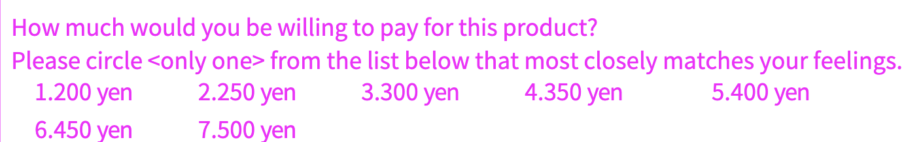

As it turns out, however, these simple question formats often do not work. When the product is introduced to the market, the price is often too high and consumers shy away from it, or the price is too low, and the product is perceived to be of poor quality.

## Overview of PSM Analysis Technique

The method of PSM analysis itself is extremely simple.

### (1) Conducting surveys

The PSM analysis requires only four questions.

1. At what price would you consider the product to be so expensive that you would not consider buying it?
2. At what price would you consider the product starting to get expensive, so that it is not out of the question, but you would have to give some thought to buying it?
3. At what price would you consider the product to be a bargain - a great buy for the money?
4. At what price would you consider the product to be priced so low that you would feel the quality couldn't be very good?

That's it.

The beauty of the PSM analysis is that these four questions are all you need to do. There is no need to design and pay for a PSM survey. You just need to add a little bit of it to your existing surveys.

### (2) Tabulation of Survey Result

Suppose we ask 36 consumers the above four questions about a certain product, and the results are as shown in the following table.

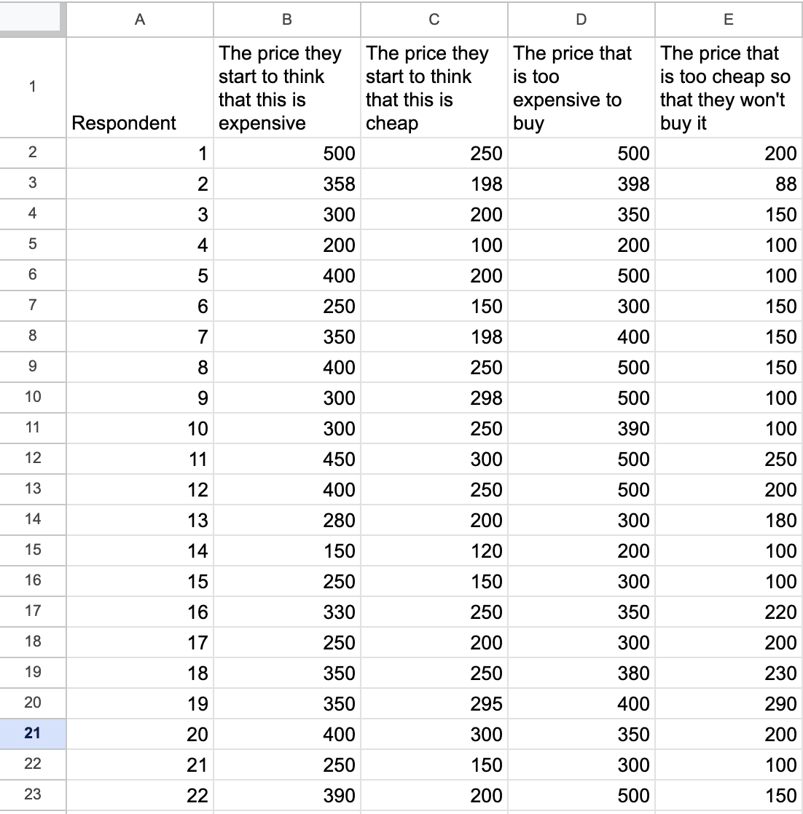

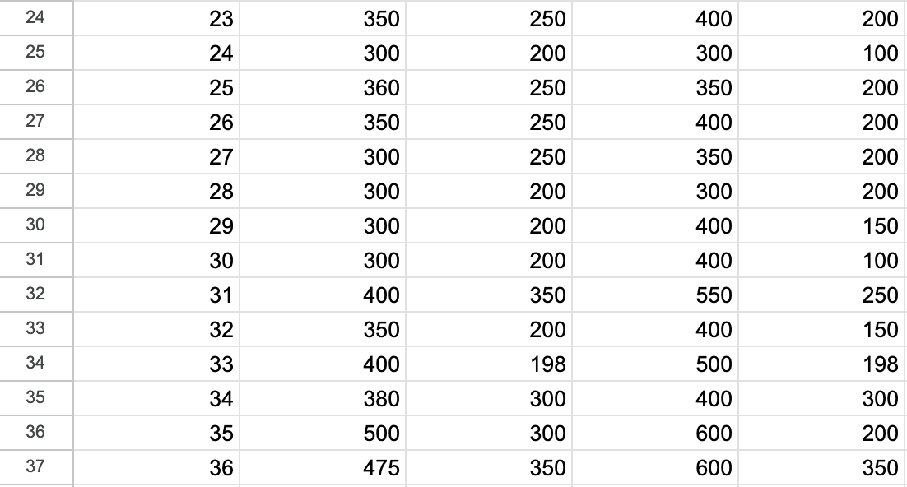

To analyze the data, we must first tabulate what percentage of respondents considered a price to be "too expensive," "too cheap," "too expensive to buy," or "too cheap to buy."

If the unit of response is in units of one yen, then the basic method is to tabulate the percentage of respondents who thought the price was "too expensive", "too cheap", "too expensive to buy" or "too cheap to buy" in units of one yen between the minimum and maximum of the four prices listed above. However, if there are few responses in units of 1 yen and many responses in units of 10 yen, it may be acceptable to tally the results in units of 10 yen. Please note that using too rough a unit of aggregation will result in results that are far from accurate data.

Here, due to space limitation, we will ignore accuracy and use a unit of 50 yen.

For example, to find the percentage of respondents who thought that 50 yen was expensive, count the number of respondents whose answer to the question 'the price at which you start to think it is expensive' was 50 yen or less, and divide this by the total number of respondents. This can be achieved by using Excel. COUNTIF function could be used to count the number of respondents whose answer to the question 'the price at which you start to think it is expensive' was 50 yen or less. The COUNT function could be used to count the number of respondents. Please see below references regarding these two functions

[COUNT function reference](https://support.microsoft.com/en-us/office/count-function-a59cd7fc-b623-4d93-87a4-d23bf411294c#:~:text=The%20COUNT%20function%20counts%20the,range%20or%20array%20of%20numbers.)

[COUNTIF function reference](https://support.microsoft.com/en-au/office/countif-function-e0de10c6-f885-4e71-abb4-1f464816df34#:~:text=Use%20COUNTIF%2C%20one%20of%20the,want%20to%20look%20for%3F))

Using these functions, we can tabulate above data as follows

### (3) Creation of Graph

We will now graph this aggregated data.

In Microsoft Excel, you can choose a "scatter plot (lines and markers)" graph with price on the horizontal axis and response rate on the vertical axis. Although a "scatter plot (smooth lines and markers)" graph is more beautiful because of its smoother lines, a scatter plot (straight lines and markers) is chosen graph here for a certain reason that will be explained later.

## Four Prices that can be Found in PSM Analysis

These four graphs will produce four intersections. The four intersections are referred as below

* Intersection of "too expensive to buy" and "too cheap to buy" → "highest price."
* Intersection of "expensive" and "inexpensive" → " compromise price
* Intersection of "too expensive to buy" and "too cheap to buy" → "ideal price."
* Intersection of "too expensive" and "too cheap to buy" → "guaranteed quality minimum price."

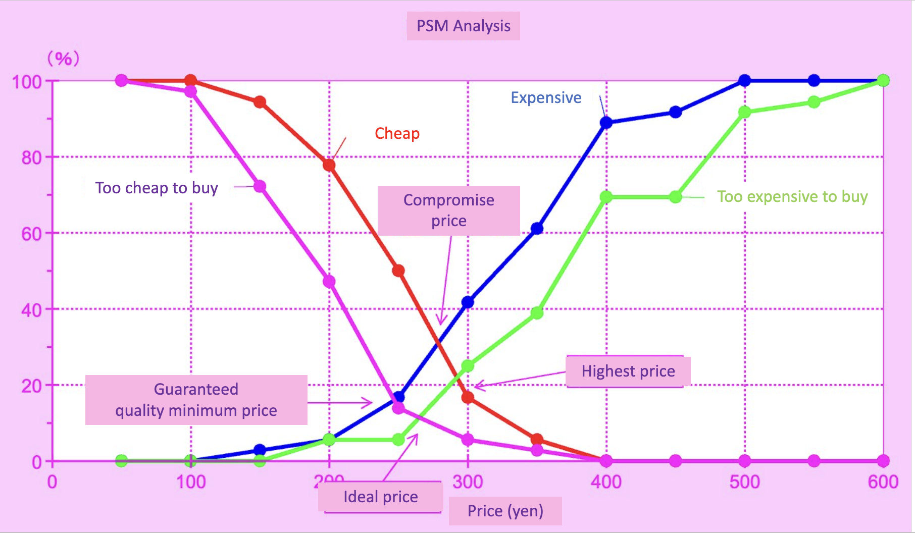

Highest Price

This is the price point where the "too expensive to buy" graph and the "too cheap to buy" graph intersect. This is the price point at which "no one will buy it if you price it any higher. For products that are positioned as luxury or professional, these prices provide the best results. Premium pricing is also the most efficient pricing method for products in non-traditional categories or with added value.

### Compromise Price

This is the price point where the "expensive" graph and the "cheap" graph intersect. The intersection of these prices is the price at which a competitive compromise is reached. Usually, compromise price will be close to the price of the product with the top market share.

### Ideal Price

This is the price point where the "too expensive to buy" graph and the "too cheap to buy" graph intersect. Both the price at which one begins to think that the product is too expensive to buy and the price at which one begins to think that the product is too cheap and that there may be quality problems. This intersection represents the price at which the fewest number of people that are less likely to buy and the largest number of consumers that are most likely to buy. In most cases, it’s a bit lower than the compromise price. This price is characterized by the best possible balance between sales volume and profit. However, it is often difficult to set the ideal price due to manufacturing cost issues.

### Guaranteed quality minimum price

This is the price point where the "too cheap to buy" graph and the "too expensive" graph intersect. In a nutshell, this is the price point at which consumers begin to suspect that the quality of the product may be poor if the price is reduced any further. In addition to being useful for pricing in the case of popularly priced products, this price is also a good reference for special sales in supermarkets. At this price, sales volume increases but profits do not increase. Therefore, it is best suited for pricing low-priced products in the equipment industry, such as cigarettes and audio tapes, where the ratio of fixed costs falls sharply as the volume increases.

The range between the compromise price and the ideal price is called the "reasonable price range", and the range between the highest price and the lowest quality assurance price is called the "acceptable price range”. When setting the price of a product, it is best to set it within the reasonable price range if possible, and even if it is difficult to do so, it is best to at least set it within the acceptable price range

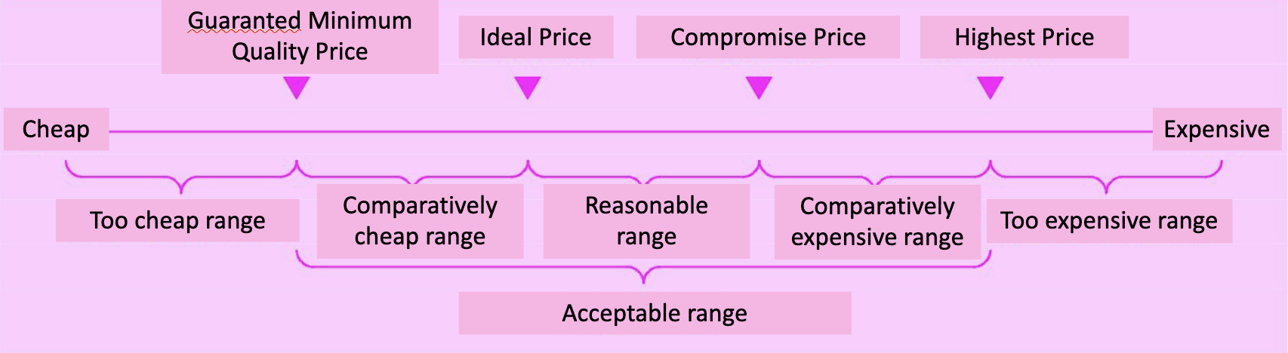

In the graph above, the four prices are arranged in the order of "guaranteed minimum price < ideal price < compromise price < maximum price," but the actual data may not be arranged as neatly as this. For example, it may happen that "ideal price > compromise price". In this case, it is likely that consumers are willing to pay more. The fact that consumers are willing to pay more is a sign that they want a higher value-added product.

### Calculating the four prices

Now let's calculate exactly how much the maximum price, compromise price, ideal price, and guaranteed quality minimum price are, respectively.

If the data is aggregated in units of 1 yen, the graph or the aggregate data will tell you how much each price is without having to calculate it every time. However, if the aggregation units are set in units of 10-yen, 50-yen, or 100-yen, the value of the intersection of the graphs cannot be determined just by looking at the graph or the aggregate data. The value of the point of intersection must be calculated.

In fact, the reason we chose a "scatter plot (line and marker)"graph instead of a "scatter plot (smooth line and marker)"graph when creating the graph was to make this calculation easier. For example, looking at the highest price, the graph of "too expensive to buy" and the graph of "too cheap to buy" intersect between 250 yen and 300 yen, so we can find the intersection only by using the equation of the straight line between 250 yen and 300 yen in each graph. For example, the intersection between "too expensive to buy" and "too inexpensive to buy" is x = 292.12.... It means that the highest price is 293 yen. Similarly, the compromise price is 279 yen, the ideal price is 265 yen, and the guaranteed quality minimum price is 247 yen. Therefore, the appropriate price range is 265-279 yen, and the acceptable price range is 247-293 yen, which means that it is appropriate to set the price around 270 yen first.

A similar analysis method to the price sensitivity analysis (PSM analysis) is the "purchase response curve" method. Price sensitivity analysis (PSM analysis) asks four questions: "price at which you start to think the price is too high", "price at which you start to think the price is too low", "price too high to buy", and "price too low to buy". The data can be analyzed to derives four types of prices: "highest price", "compromise price", "ideal price" and ,"guaranteed quality minimum price," from the results of these questions, whereas The purchase response curve asks two questions, "too low price" and "too high price," and derives "the price that consumers are most likely to accept" from the results of the answers to these questions. For more information, see "Purchase Response Curve" in "Analytical Methods Used in Marketing.

### Reference: Finding intersection between two lines

Intersection point of two lines is the point where two lines meet each other.

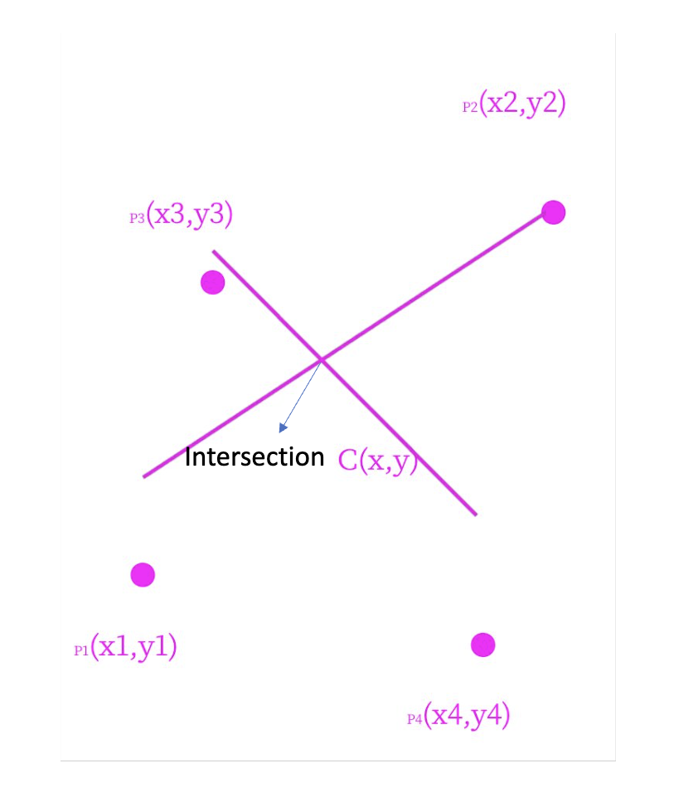

For a line created by point (x1, y1) and (x2, y2), the equation for that line is

Similarly, for a line created by point (x3, y3) and (x4, y4), the equation is

The intersection point (x, y) fulfills both above equations. Solving the above equations, we get

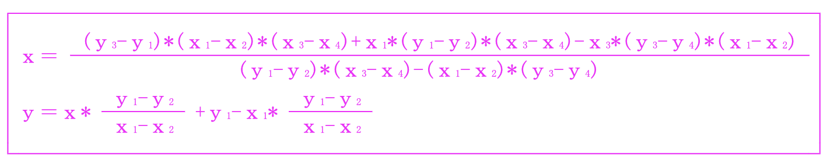For example, in Excel,

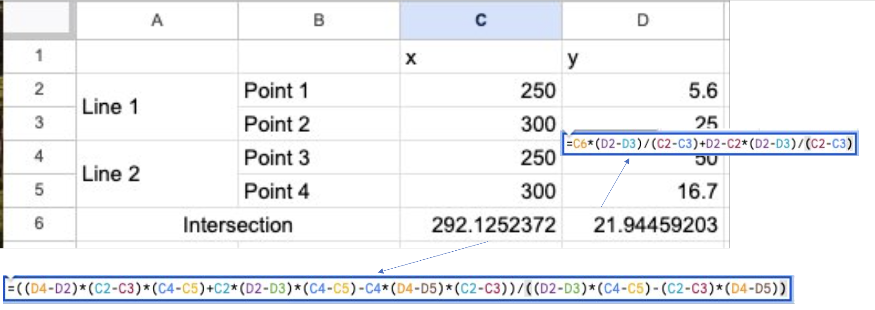

## Example: PSM Analysis of Dumpling Flour

Here are some examples of PSM analysis. We asked the following four questions about the price of dumpling flour.

1. At what price would you consider the product to be so expensive that you would not consider buying it? ... yen
2. At what price would you consider the product starting to get expensive, so that it is not out of the question, but you would have to give some thought to buying it? ... yen
3. At what price would you consider the product to be a bargain - a great buy for the money? ... yen
4. At what price would you consider the product to be priced so low that you would feel the quality couldn't be very good? ... yen

PSM analysis of these four prices resulted in a guaranteed quality minimum price of 300 yen, a compromise price of 331.1 yen, an ideal price of 332 yen, and a maximum price of 355 yen. Thus, the appropriate price range is 331- 332 yen.

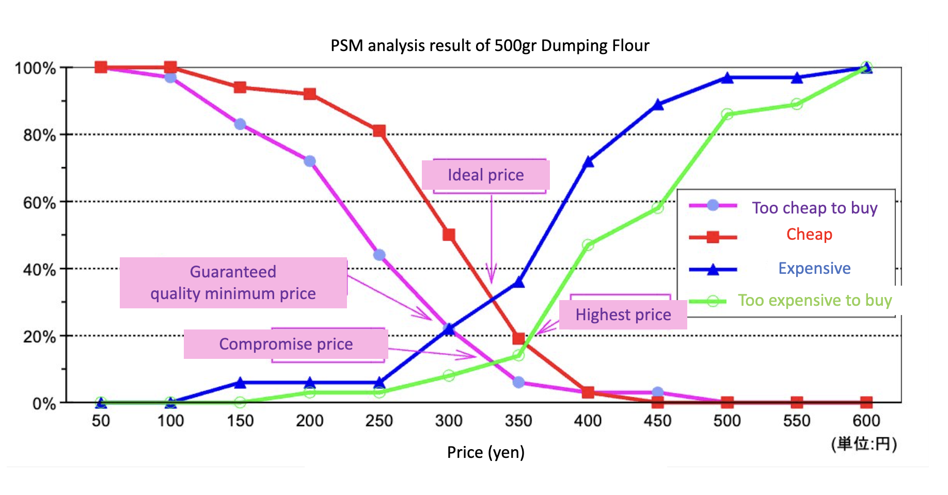

Source: https://www.pref.miyagi.jp/documents/20321/617766.pdf